Patient: 1968 Evinrude, 55 HP, Two Stroke, Outboard Boat Motor

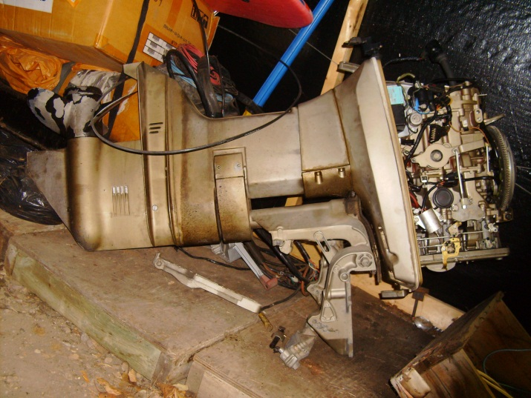
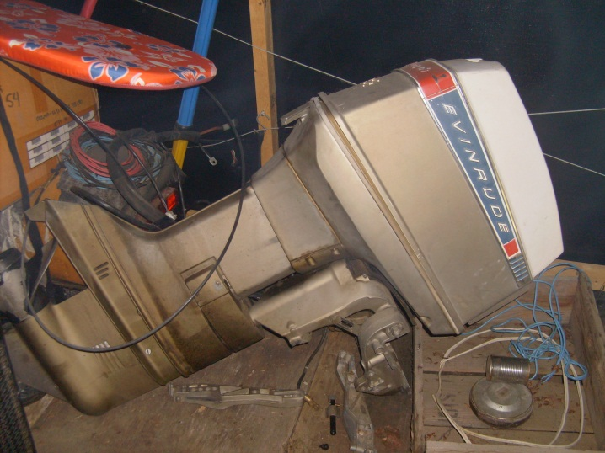

Diagnosis: Removed from service due to unreliable ignition system.

Cause: 42 year old points triggered “electronic” ignition.
Worn and obsolete distributor cap and rotor mounted under flywheel.

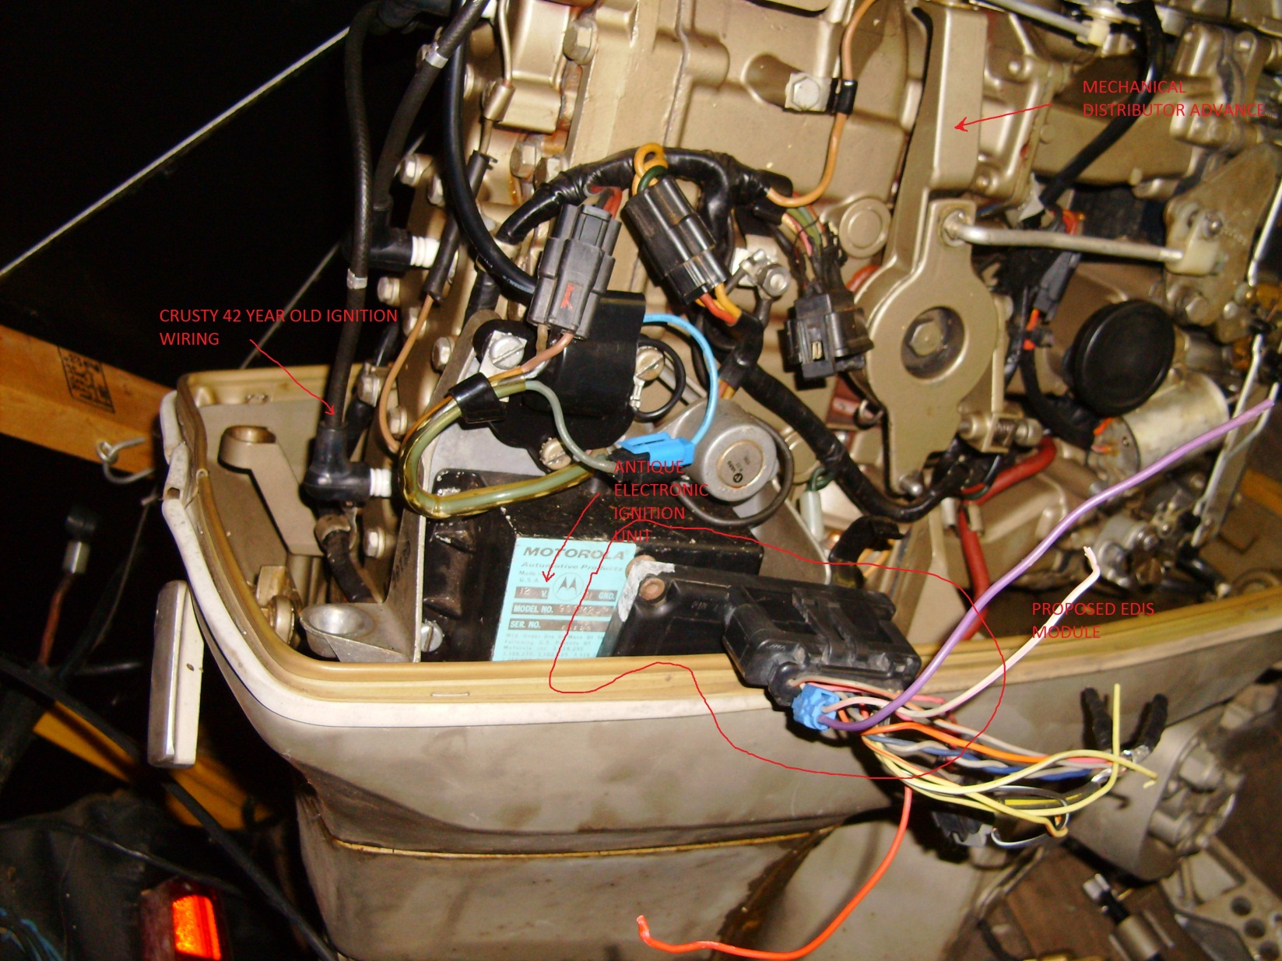

Project Objective: Build / Adapt modern ignition system to motor.

Black text courtesy of Bowling & Grippo / Megajolt

All experimentation was done using an EDIS-8 module, Ford part # F1AF-12K072-AD1D07A, from a 1997 Crown Victoria (police-issue) with a 4.6L Romeo engine.

For EDIS-4, look for 1990 - 1993 1.9L engines,
EDIS-6 on 1990 - 1995 4.0L engines,
EDIS-8 on 1990 - 1997 4.6L engines.
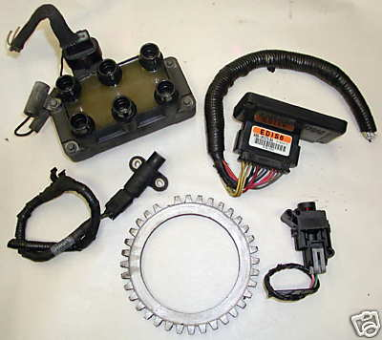
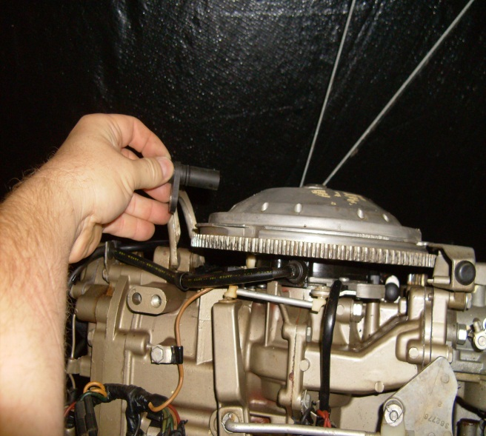
The engineers at Ford deserve a big "pat on the back" when they came up with this system - it is an excellent example of distributed control. In fact, the whole EDIS system handles the complete task of crank/ignition synchronization as well as current sourcing for the wasted-spark coils. The task of generating the desired ignition advance is performed by the ECU. (engine control unit)

The crankshaft is fitted with a 36-tooth wheel, with one tooth missing in order to provide crankshaft indexing.

Project scope – build 36 tooth ferrous trigger wheel to bolt to flywheel (aluminium gear on the top of the motor), and suitable mounting for VR sensor. DG

The EDIS system is a wasted-spark setup (i.e. three spark plugs fire which are separated by 360 "cycle-degrees" of a 4-cycle engine), as such no synchronization with the camshaft is required.

For the boat motor application, the motor is two stroke, and therefore must fire on every stroke. Using an EDIS 6 module, the “waste spark” will actually be used on every second stroke, therefore there will no longer be a “wasted spark”. DG

Near the toothed trigger crankwheel (radially-situated from the crankwheel centerline with a 0.030 to 0.060 inch gap) is a Variable-Reluctance (VR) sensor - this sensor produces a bi-polar signal very similar to a sine-wave when passing each tooth of the crank trigger wheel. This resultant signal is fed directly into the EDIS module, indicating crankshaft position (every 10 degrees crank). With the VR signal, the EDIS module can synchronize with the engine crankshaft. The missing pulse allows the EDIS module to calculate absolute crank position and then correction every 10 degrees by way of the remaining pulses.

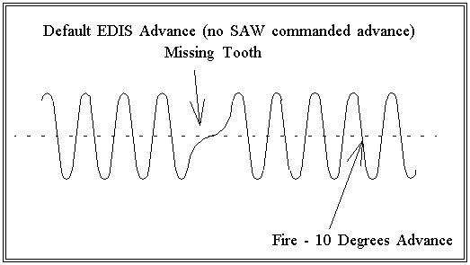
(Simulated) VR signal generated from the crank wheel, and the EDIS-6 firing point for coil #1:

When the EDIS module receives proper VR signal, it generates a 12-volt square-wave signal (Ford-named PIP) which matches the falling edge of each ignition fire.

Project Scope: Scavenge EDIS-6 module from 6 cylinder engine from Ford vehicle circa 1998. Salvage variable reluctor sensor, connectors, ignition coils, and related mounting hardware.

This PIP signal is used as a reference to synchronize the generation of the SAW pulse by the ECU (engine control unit) (typically the car’s (boat’s? DG) computer). A signal is sent back to the EDIS module (Ford named SAW). This signal is a +5V positive-transitioning pulse, and the width (duration DG) of this pulse determines the spark advance that the EDIS module will use for subsequent ignition events.

Project Scope: Find or Build a device to generate the synchronous timing SAW signal that advances the firing of the ignition based on engine speed or engine load. Evinrude (remember the boat motor?) used a mechanical advance system that was tied to throttle position. Solution: – Pending. DG

Note that the SAW pulse must be synchronized with the PIP negative-transitioning pulse - it cannot be applied asynchronously to the PIP signal, (Note to self, “advance pulse duration must by synchronous to the PIP signal - which changes with engine RPM – can’t be that hard . . . ) otherwise incorrect advance commands will be interpreted by the EDIS module. Here is the proper relationship between the two signals:

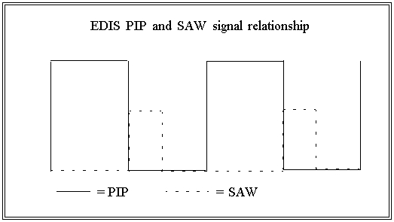

SAW (microseconds) = 1536 - (25.6 * Commanded_degrees)

So, the width of the SAW word in degrees is related to the desired advance by the above equation.

Applied SAW Pulse Width(us) | Resultant Increment in Degrees of Spark Advance
1280 | 10
1024 | 20
896 | 25
768 | 30
512 | 40
256 | 50
128 | 55

The EDIS module has the actual ignition coil driver built-in - the driver is not part of the Ford wasted-spark coil pack. The coil packs are just standard ignition coils, and could in theory be substituted with other coil-only packs.

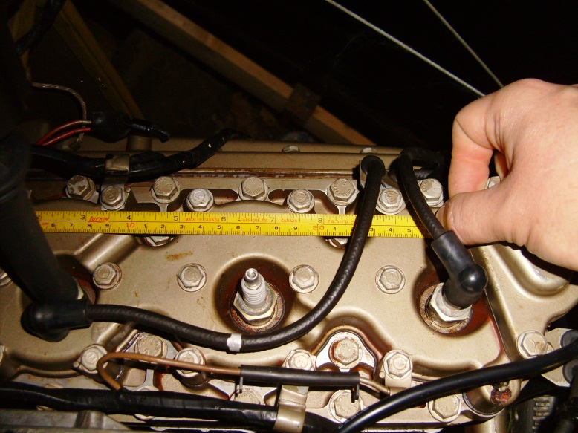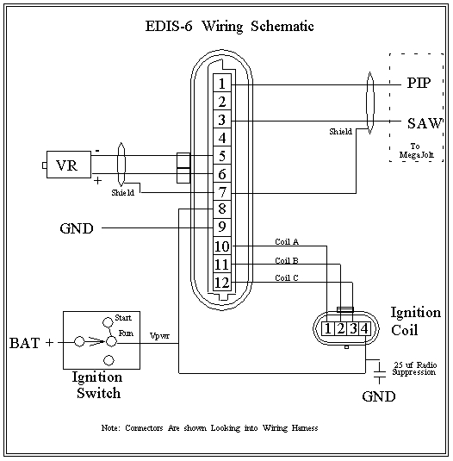

Excellent, instead of using the triple coil, 6 primary lead coil pack, I intend to substitute 3 coil on plug ignition coils from a late model ford car engine. Hmm, guess I didn’t need to scavenge the 6 cylinder car engine ignition coil now did I. DG

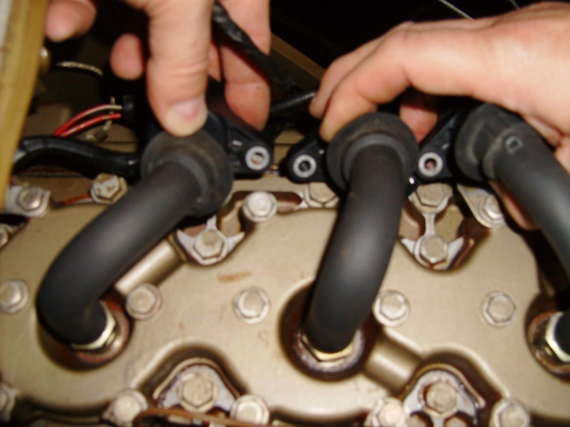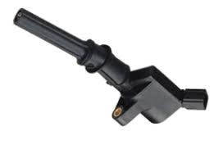

EDIS module handles the dwell-time automatically, depending on commanded advance and RPM.

The EDIS ignition system is rugged - the module mounts under-hood and will survive engine-bay temperatures, water, freezing, etc. (PIP and SAW) (Salt Water? DG)

Update, September 2012

So the owner of Free Spirit Marine gets a copy of the story to this point and is fascinated by the idea of grafting new automotive junkyard technology to old and nearly abandoned motors and decides that having a boat motor with no boat is not okay. So he searches the back lot and offers up a free* boat.

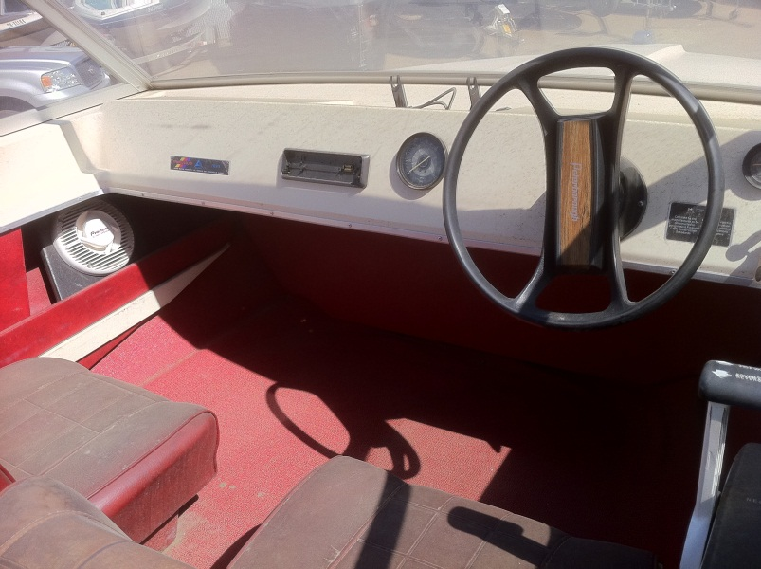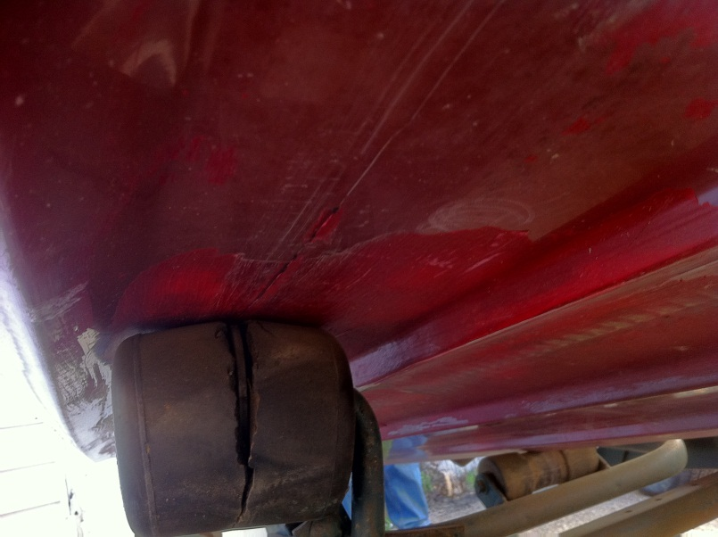

Excellent. It only has a little crack / hole in it. And doesn’t come with the trailer.

But he says, if you want a little better boat, that won’t sink immediately, I will part with this orange beauty (next page), at my cost for the good of the project. Done. I figured that the last thing that I have is extra spare time to patch a fiberglass hull and have to worry about sinking AND having a motor that doesn’t run in the middle of the lake.
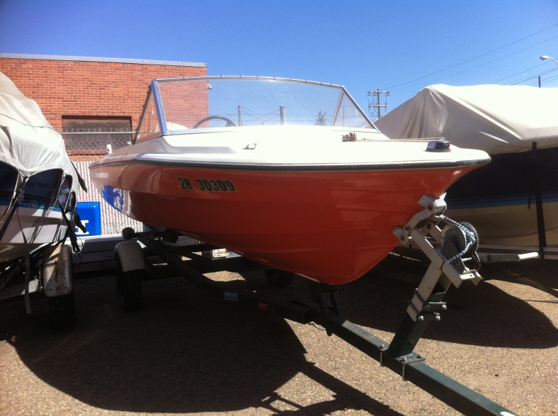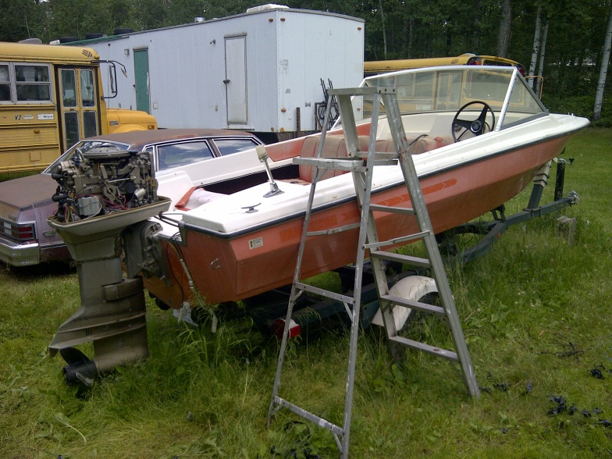

So: Boat meets motor and the installation begins.

Enter the cost benefit analysis again, and the significant task of constructing the timing computer becomes a rationalization to order up a MegaJolt Light. http://www.autosportlabs.net/MJLJ_V4_vehicle_installation_guide. $161.95. + SH

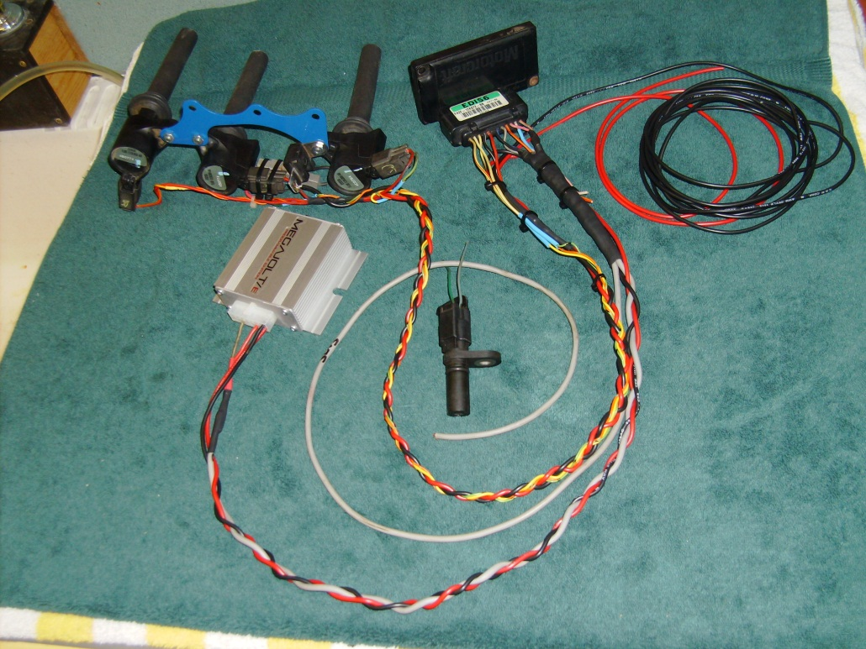

A couple of evenings later, and the replacement ignition system is born.

This schematic is the original motor and drive console wiring deciphered from the really cryptic and not totally correct version in the OMC book.

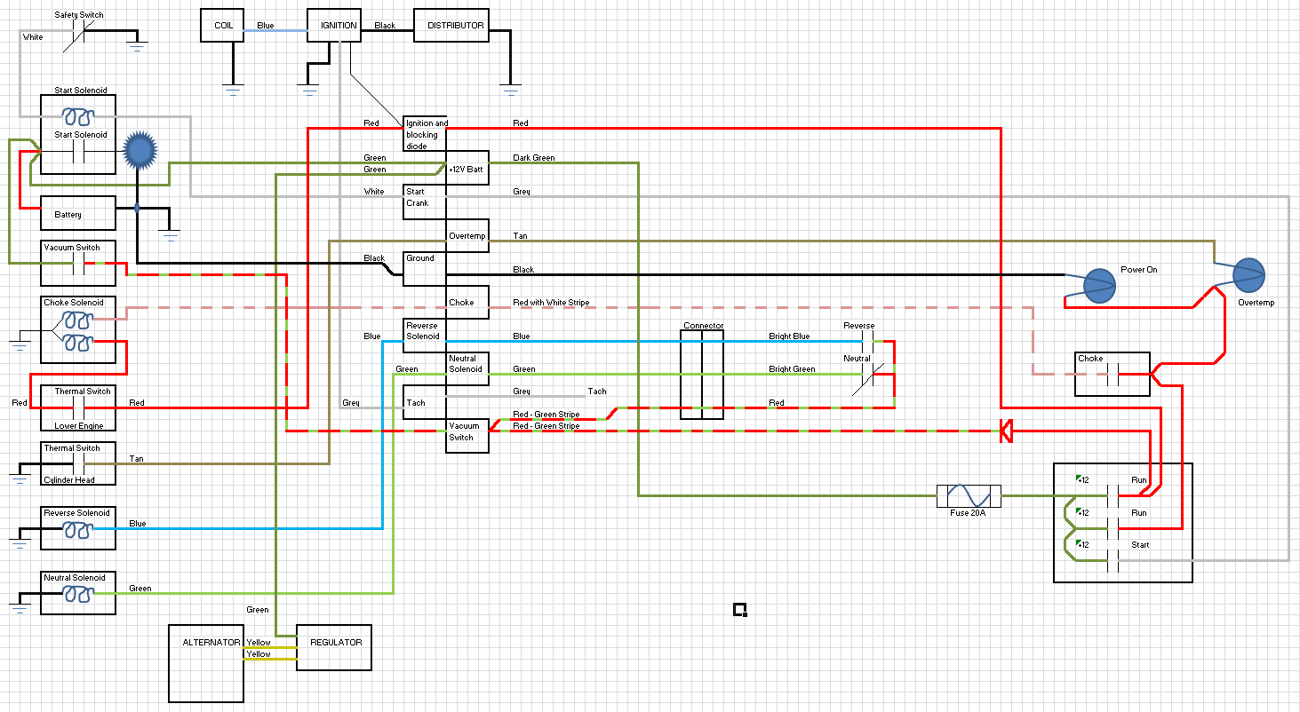

This is the revised wiring with the MegaJolt Jr, EDIS, and coil pack as installed.
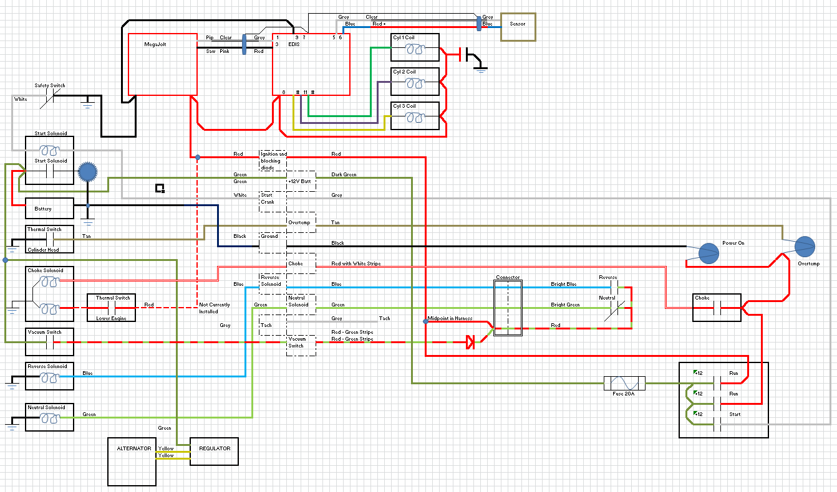Next page shows some of the foolishness of assembly and programming, as well as some screen shots of the computer program screen.

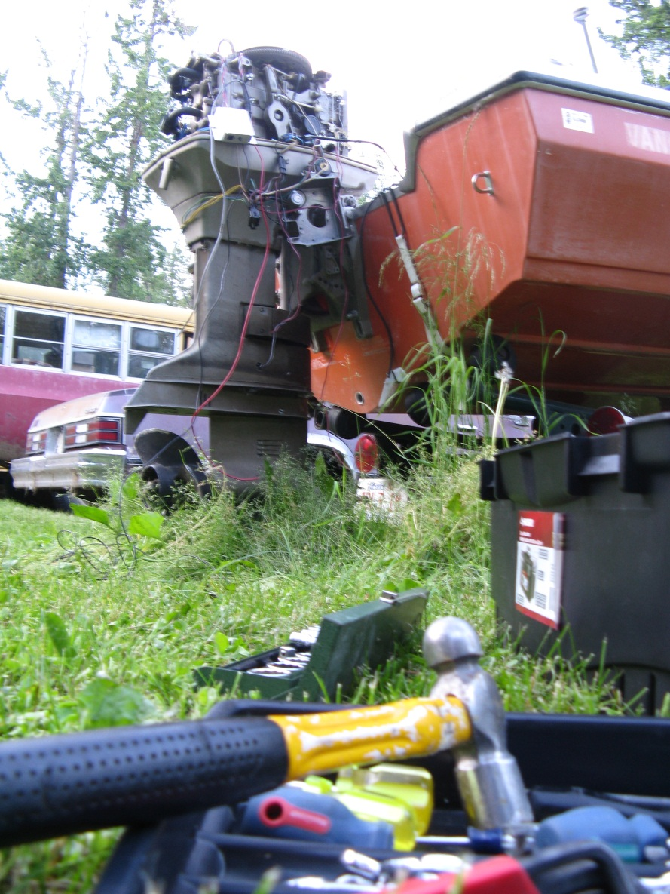
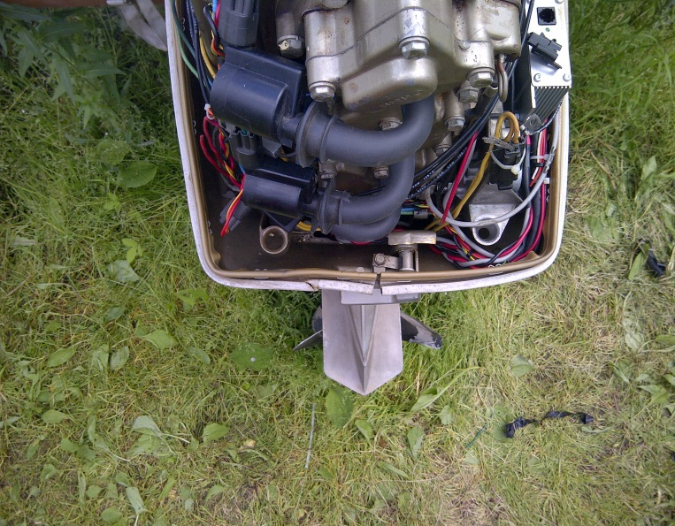
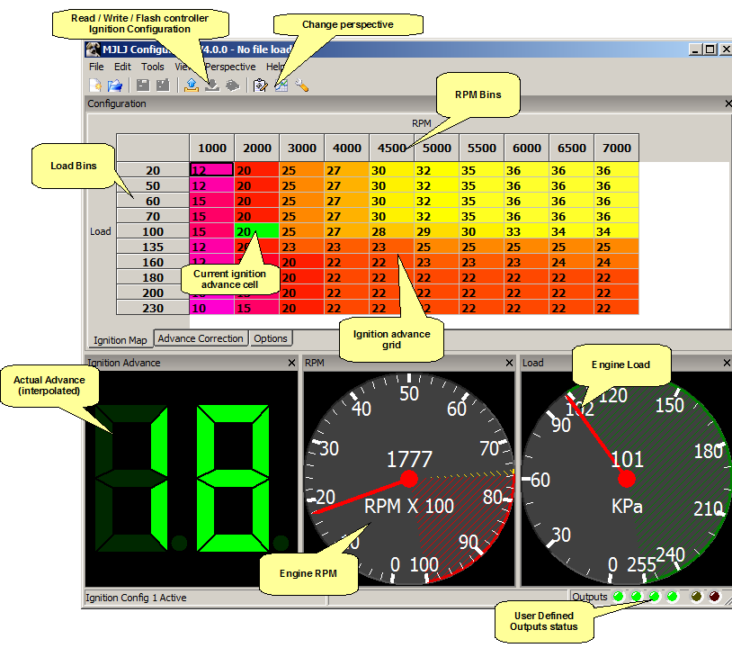
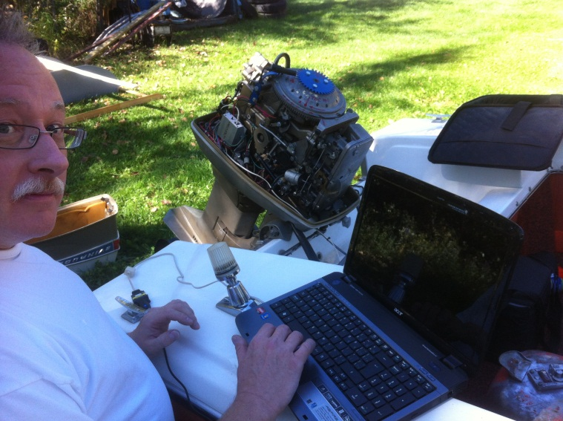
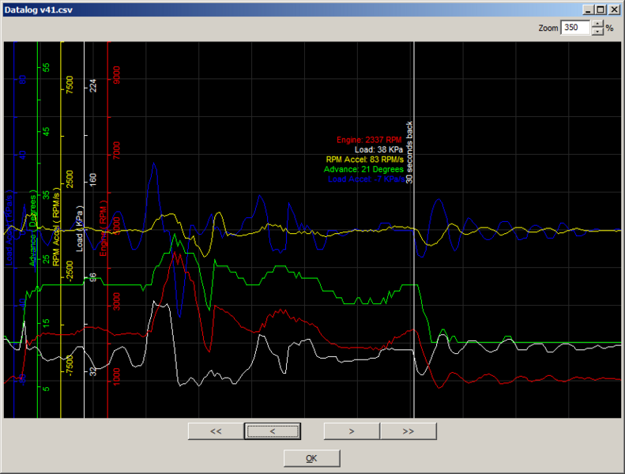
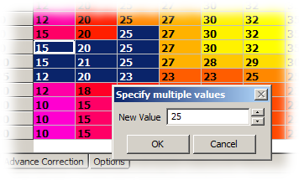
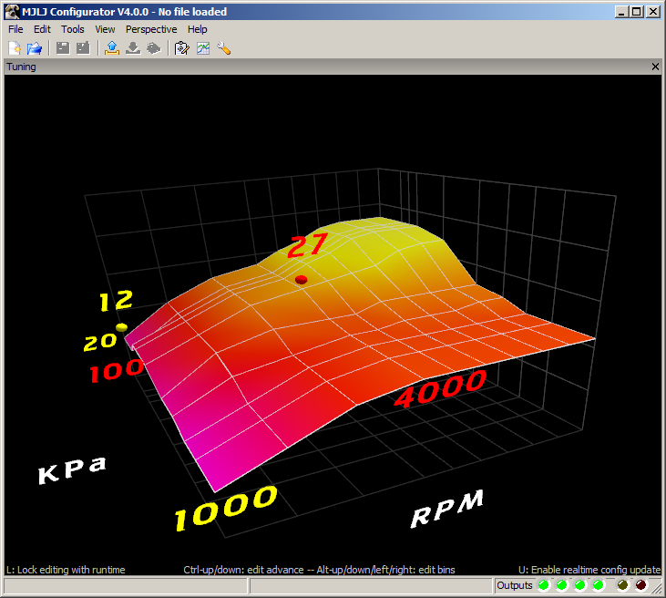

Allrighty – here I am in Mulhurst Bay at Pigeon lake in late September, 2012; with an engine that runs, a boat that floats, with my OMC book in hand, reading about troubleshooting the solenoid operated transmission. It would appear that the long storage duration has gummed up the works inside the drive leg and requires a bit more than just shaking it loose once it is running again. Apparently I have a new project to learn the mechanical ins and outs of drive legs and hydraulic transmissions . . . . . .

PART II – BOAT GEARBOXES

A bit of explanation. The selection of forward, neutral and reverse is done by shifting a dog clutch (20) forward and aft on a splined shaft (23), between two counter-rotating gears (18 & 24) driven by the pinion (36) on the driveshaft (39) from the power head (engine).

Movement of the dog clutch is spring driven (61) into forward, and hydraulically driven by a piston (62) in a bore (6) into neutral and reverse from oil pressure derived from the hydraulic pump (5). The control valve which directs the oil flow (57) is up springs (55) and driven down in two stages using two solenoid coils (54). Position of the spool valve is set by adjusting the threaded endplay of the brass rod.

The initial disassembly in May of 2013 reveals a basic simple problem. The rod connecting the spool valve to the electric solenoids is bent. The valve has come out of the valve bore and cannot be actuated by the solenoids. Simple fix! Carefully straighten the rod, pop the spool valve back into the bore, check the solenoids for operation before reassembly done! For the record, there has never been a satisfactory explanation for the bending of the rod. The rod worked when the motor was used with points ignition, it got taken off one boat, stored for a couple years and put on another boat. Magically it got bent. We can’t explain how. We do know that the motor was dropped rather heavily during this period but that still doesn’t really explain how bent it really was.
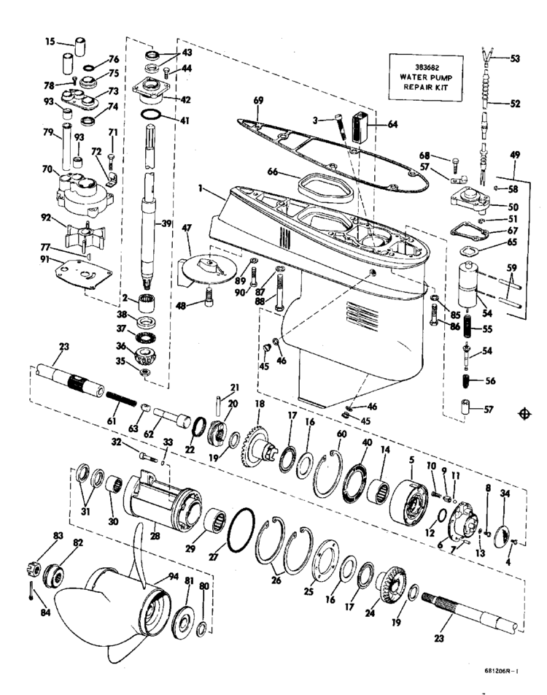
So the boat gearbox is a hydrodynamic magical thing. Looking reasonably engineered on paper, but one which behaves without regards to the laws of physics in the real world.

Or to put it another way, what worked on the bench under a powered test using an electric motor driving the driveshaft (30) didn’t work in the water. Forward worked, reverse worked but no neutral. Solenoids tested fine, lots of experimentation with additional grounding, resistance measurements, current measurements, diode checks, it all tests out, but no neutral.

A couple more attempts at disassembly and reassembly took place, fresh fluid, more bench tests. Still unpredictable behavior.

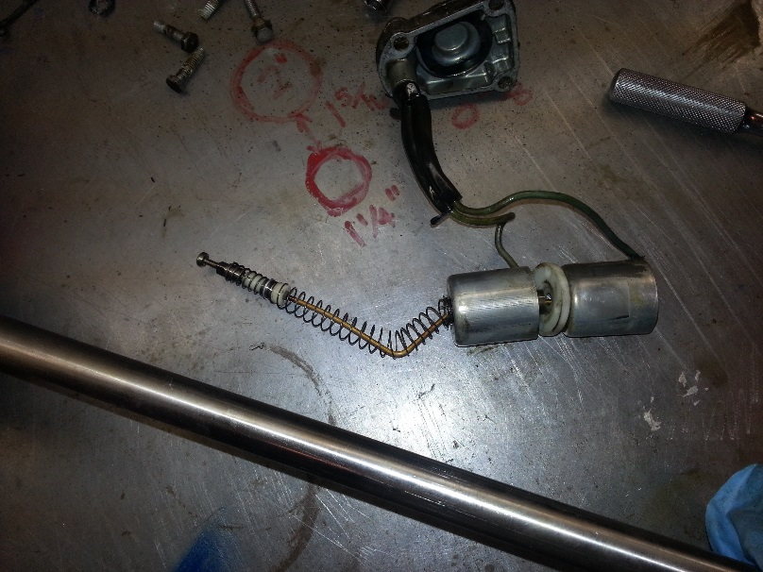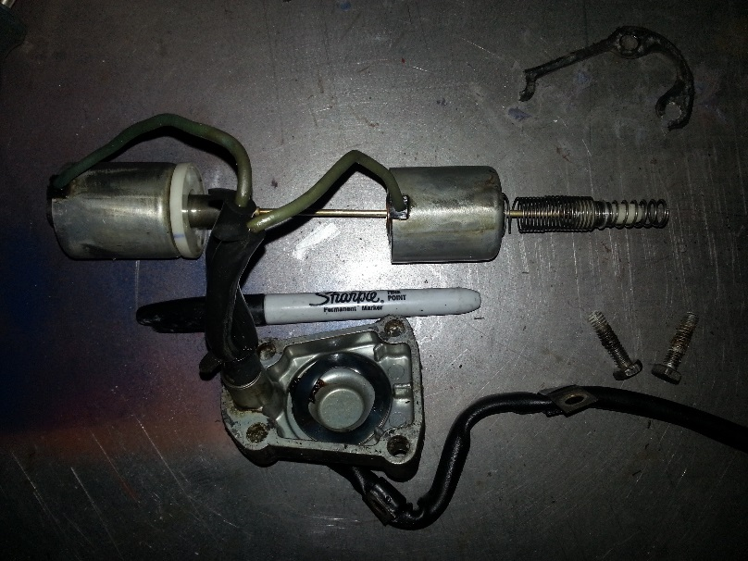The bent shaft as removed in the spring of 2013. The repaired shaft as reinstalled in the spring of 2013.

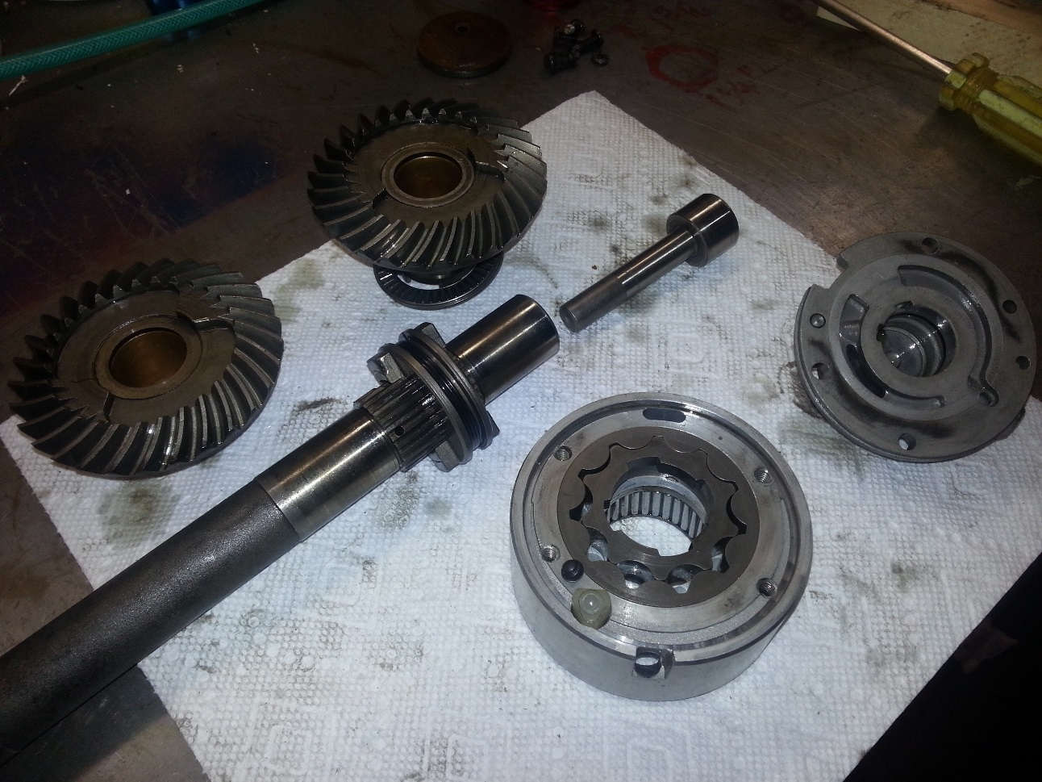
The piston, pump, piston bore, dog clutch, forward gear and reverse gear. Some abnormalities were found on the check ball on the pump (small black ball lower middle of picture, sitting near pump gears) A steel ball was put in as a replacement.

Spring 2015. Total dissassembly of the lower end, replacement of any dubious parts, including the water pump main driveshaft bearings, seals and anything else that looked suspect. Reliable operation of the solenoids was assumed to be an onoing issue so they were replaced with the fully electronic digital SERVO! No more spings and magnets! The solenoids made way for the servo and arduino controller. Three pushbuttons to move the servo to pregrogammed positions. Bench tested again with the electric motor drive to ensure the movements were reliable. And just to add some on the lake adjustability, the servo positons are field fine tuneable and resettable from the controller. Each transmission position could be fine tuned with an up/down pushbutton. So a degree or two of adjustment would be certain to ensure the ideal setup.
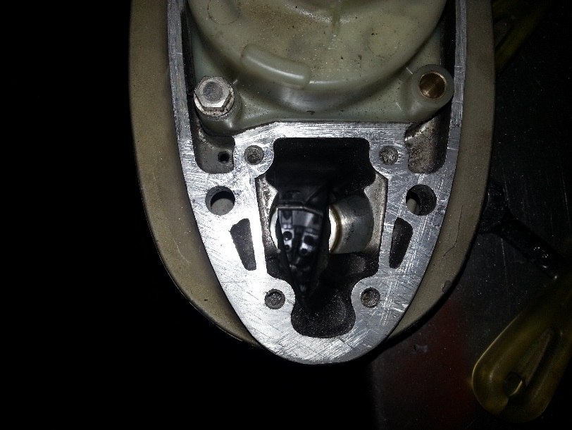
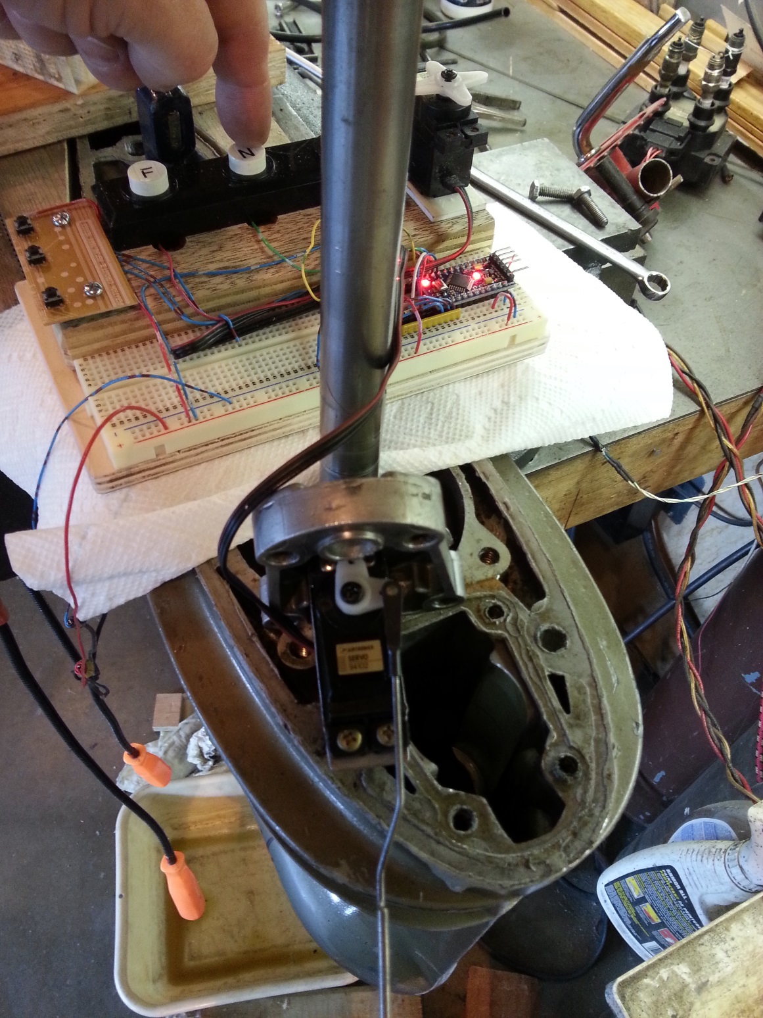
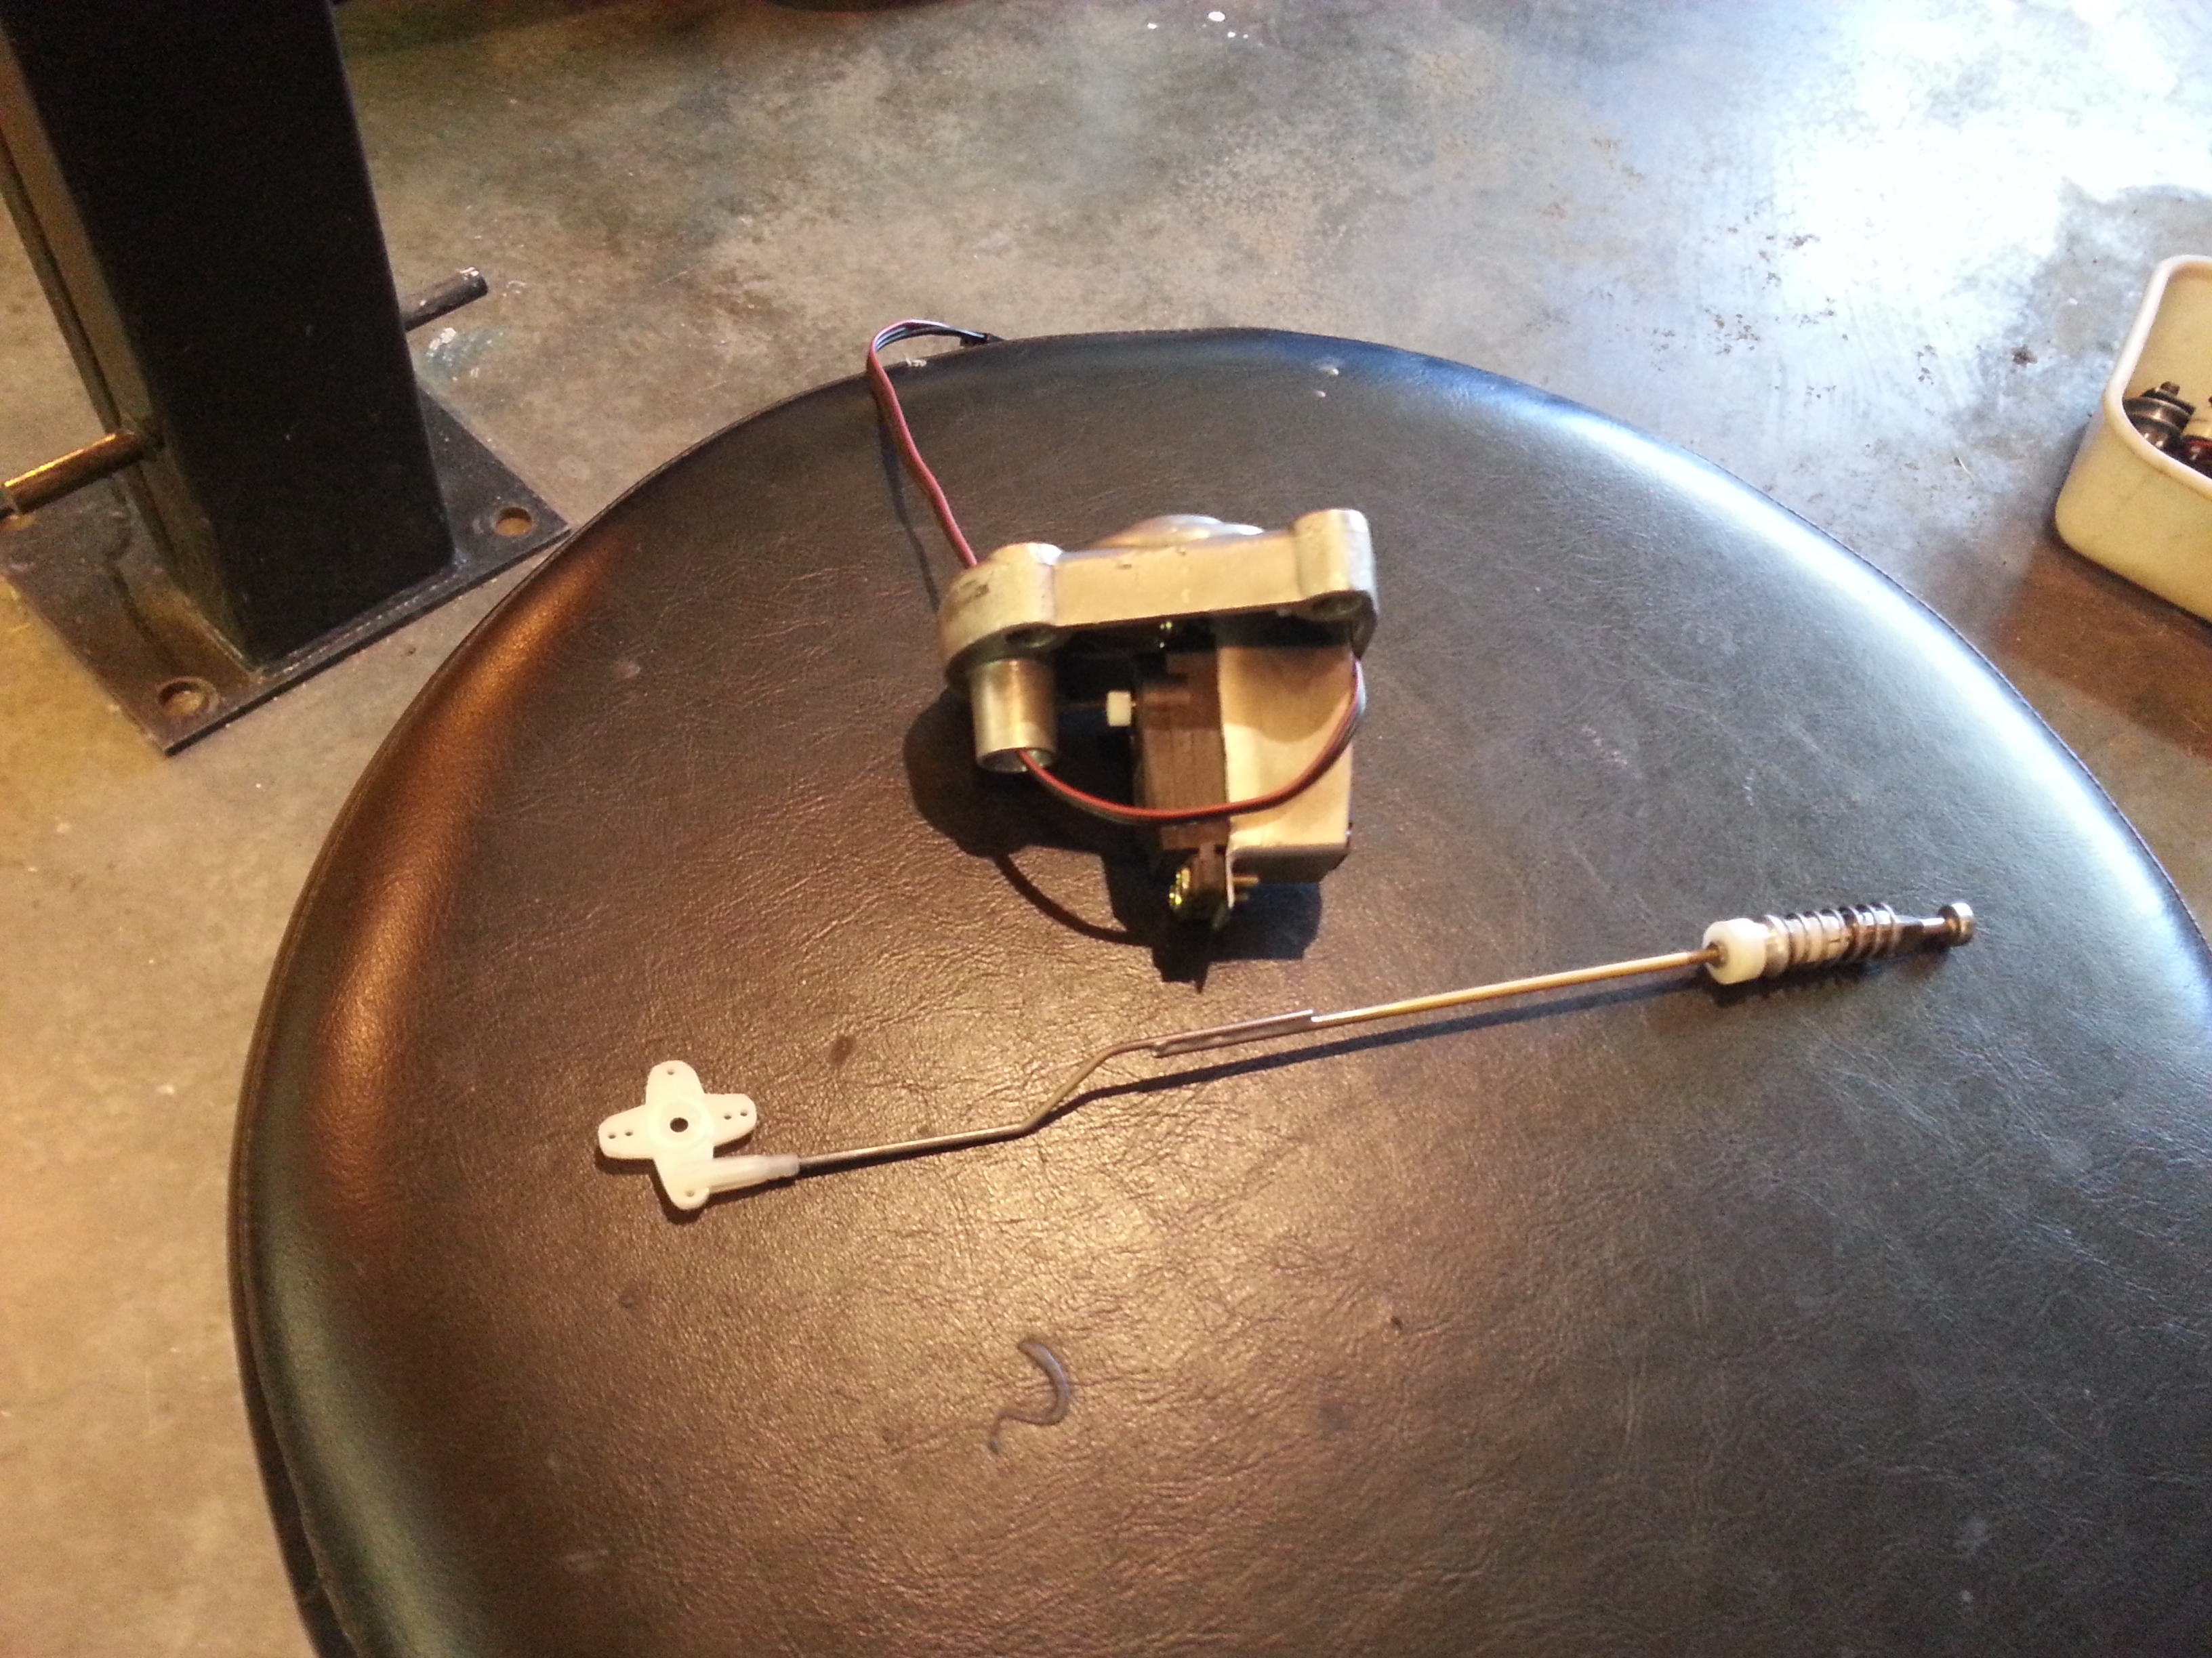Top Left: the servo, mounting bracket, servo bellcrank, pushrod arm, spool valve, and cover.

Top Right: The spool valve / solenoid bore in the leg, going down to the hydraulic piston case

Left: The prototype Arduino controller with pushbuttons and trim buttons

Below: The finished hand controller for the boat operator, complete with Power and Neutral Indicator Light

